Clinical Audit Surveys

Survey design, sampling, data management, and analysis practical sessions

January 2001, Mark Myatt

Section One - Clinical Audit

Background to the clinical audit survey exercise

Your task in this extended exercise is to develop a plan for a clinical audit survey of the routine examination of diabetic patients in a single primary health care centre.

This manual is intended to guide you through the exercise and contains background information required to complete the exercise, some practical advice to help you complete the exercise, and a series of practical tasks for you to complete.

The SampleXS sample size calculation program that is used in this exercise is to be found on the supplied floppy disk. Instructions for starting SampleXS under different operating systems are shown in the table below:

System | Instructions
Windows 95, 98, NT 4.xx, 2000 | Select the Run … item on the Start menu. In the Run dialog box type:  a:\samplexs  and click the OK button.

SampleXS is a 32-bit Windows program and may also be run under 32-bit Windows emulation on system running UNIX / LINUX.

The dataset used in the data analysis practical (AUDITEYE.REC) may also be found on the supplied floppy disk.

Clinical audit

Clinical audit is a method of improving the care that patients receive that relies upon surveying current clinical practice. Clinical audit is a cyclical process:

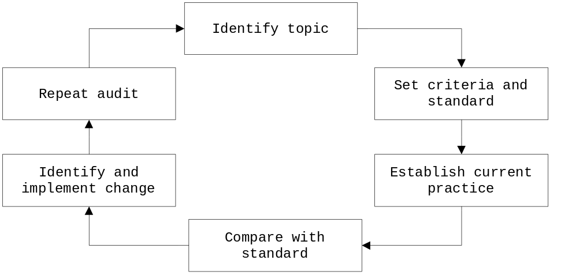

Each stage in the cycle is described in more detail below:

IDENTIFY TOPIC : This is usually an area of concern. In this exercise the topic has been decided for you (i.e. the frequency of eye examinations on diabetic patients).

SET CRITERIA AND STANDARD : Decide what should be happening and how often it should be happening. These are called the criteria (what) and the standard (how often). In the following example criteria / standard statement:

Eighty percent of diabetic patients should have had an eye examination in the previous twelve months.

Eighty percent is the standard and the rest is the criteria. It is common practice for a survey to have a set of criteria / standard statements

ESTABLISH CURRENT PRACTICE : This is the survey stage of clinical audit. In the above example you might establish current practice by reviewing a sample of the notes of diabetic patients. Audit surveys tend to be smaller and quicker than other cross-sectional surveys.

COMPARE WITH STANDARD : The results of the survey of current practice are compared to the desired standard.

IDENTIFY AND IMPLEMENT CHANGE : The survey results may indicate that a particular standard is not being met. In this case you will need to identify why this is so and make changes to improve the situation.

REPEAT AUDIT : Audit is cyclical and the survey of current practice should be repeated after (e.g.) six months or a year in order to investigate how effective any changes have been or whether further work is required.

This course module concentrates on the first four stages of the clinical audit cycle.

Clinical audit and evaluation

The processes of clinical audit and evaluation are similar and use similar techniques. The main difference between the two are:

- Audit generally applies to processes whereas evaluation generally applies to outcomes. A specific form of audit called ‘critical incident audit’ is an exception to this rule. Critical incident audit concentrates on investigating individual, often rare, negative outcomes (e.g. surgical mishaps such as operating on the wrong eye). Critical incident audits often take the form of an investigation of enquiry into a specific event or set of events.

- Audit explicitly states how often a criteria should be met (the standard) and tests a service against the standard whereas evaluation usually attempts only to discover how often a criteria is met.

- Audit is a regular, iterative (repeated), or continual process whereas evaluation is usually done only once or irregularly. This means that audit survey datasets tend to be simpler, smaller, and easier to collect than evaluation survey datasets.

The process and techniques used in evaluation and clinical audit are so similar that many of the techniques presented in this course module may also be used for evaluations. Evaluations tend to be performed by independent teams whereas audits tend to be internal to an organisation.

The audit setting

Fullchester is a small, imaginary, west-midlands town in the United Kingdom. Primary health care is delivered by a single group practice that serves the town and surrounding villages. Their are 405 identified diabetic patients attending the practice. Each diabetic patient is invited by letter to attend a diabetic clinic twice each year.

Stating the criteria and standards of the audit

An important step in undertaking a clinical audit survey is to define what criteria and standard will be used to judge success or failure.

In the context of an audit survey of the frequency of eye examination on diabetic patients, one criteria might be:

Diabetic patients should have an eye examination every twelve months.

The criteria will usually reflect good clinical practice. It is a statement of good clinical practice.

The criteria is always combined with a standard. The standard reflects how frequently a particular criteria should (reasonably) be met. It is important that the combination of criteria and standard results in a testable statement. For example we might combine the criteria ‘diabetic patients should have an eye examination every twelve months’ with a standard of 80%. This would result in the following, testable, criteria / standard statement:

Eighty percent of diabetic patients should have had an eye examination in the previous twelve months.

This criteria / standard statement may also be expressed as a question that requires a yes or no answer:

Have eighty percent or more of our diabetic patients had their eyes examined in the previous twelve months?

Use whichever format you feel most comfortable with but it is important that you set an achievable standard. Audit is a cyclical process and the standard should become more stringent over time.

It is common for an audit to have more than one criteria / standard statement. In this particular case, the set of criteria / standard statements might include:

Eighty percent of diabetic patients should have had an eye examination in the previous twelve months.

Eighty percent of diabetic patients should have had their blood pressure checked and recorded in the previous twelve months..

Ninety-five percent of patients with both hypertension and diabetes should have had an eye examination in the previous twelve months.

The criteria / standard statements for any audit should be directly relevant to the audit topic. They should be clearly and precisely defined and be able to inform all other decisions about the design of the audit survey. Without well defined criteria / standard statements there is a risk that the audit survey will not be able to answer any useful questions about the audit topic.

The criteria / standard statements should inform the audit survey sample size, the audit survey dataset and the methods of measurement to be used in the audit survey.

It is important to consider the source of data that will be used for the audit survey when defining criteria / standard statements. This will allow you to decide if a particular criteria / standard statement is a testable statement. In this particularly context, we might choose to collect data by a systematic review of patient notes.

Stating the criteria and standards of the audit

The criteria, standards, and sources of data that will be used in the proposed audit are:

Defining an audit survey dataset

The criteria / standard statements of the audit will suggest the scope and nature of the data items (variables) that will need to be collected and a broad outline of the survey dataset (i.e. the data needed to meet the aims of the survey) should flow naturally from them. Much of the survey dataset is defined directly by the criteria / standards statements. It is, however, necessary to provide a detailed description of the required dataset.

The following criteria / standard statements:

Eighty percent of diabetic patients should have had an eye examination in the previous twelve months.

Eighty percent of diabetic patients should have had their blood pressure checked and recorded in the previous twelve months..

Ninety-five percent of patients with both hypertension and diabetes should have had an eye examination in the previous twelve months.

Require the following data items be collected for each patient:

Date of last eye examination

Date of last recorded blood pressure taken

Blood pressure (or a variable indicating hypertension). If blood pressure is recorded then a sensible case-definition of hypertension is also required.

When defining an audit survey dataset always focus on the survey topic. In this exercise you should focus on the routine examination (and recording of data) of diabetic patients.

Defining an audit survey dataset

The variables you will collect in the proposed audit survey are:

Defining an audit survey dataset

Now you have a list of the variables you will need to collect to test the criteria / standard statements of your audit you should start thinking about how data will be collected, coded, and stored. You can use a framework that defines the main attributes of each variable to help you do this. The main attributes you need to consider are:

NAME : What is the name of the variable?

TYPE : What is the type of variable (i.e. the type of data that will be collected and recorded)? It is easiest to think in terms of variables being either numbers or text.

LENGTH : How many numbers or letters will the variable have to hold?

CODES : Which codes will be used to represent different categories of a variable?

For example, you may have a variable that holds the sex of each respondent using the number ‘1’ to indicate that the respondent is male and the number ‘2’ to indicate that the respondent is female. In this case you might decide to use a NUMBER type variable called SEX of sufficient LENGTH to hold a single digit.

Here is an example of some variable definitions:

Name | Type | Length | Codes
DIAB | Number | 1 | 1 = IDDM  2 = NIDDM
HYPER | Number | 1 | 1 = Yes  2 = No
EYEDATE | Date | 10 | None
BPDATE | Date | 10 | None

Sometimes the choice of codes may be obvious (e.g. DIAB) but may be more difficult to define for other variables. It is often helpful to draw up a set of possible and useful coding schemes before deciding which one to use. Do not finalise coding schemes until you have piloted the audit survey questionnaire (data-collection form) and audit survey data-systems.

Defining your dataset in this way will make it easier to design data collection forms and computerise data-entry, data-management, and data-analysis.

Defining an audit survey dataset

Define the variables you have decided to collect in the previous exercises in terms of their names, types, lengths, and codes:

Name | Type | Length | Codes

Prepare the audit survey data collection forms

Data collection forms are used for recording of the audit survey dataset. The data collection form will accurately reflect the dataset and should be clear and easy to use. It should also show coding and routing instructions.

Here is a data-collection form that might be used to record basic audit survey data:

Eye Examination Audit Data Collection Form

Patient Number |__|__|__|__|__|__|__|__|

Diabetes |__|

1 = Type 1 (IDDM)
2 = Type 2 (NIDDM)

Date of last recorded eye examination |__|__|__|__|__|__|__|__|
D D M M Y Y Y Y

Date of last recorded blood pressure |__|__|__|__|__|__|__|__|
D D M M Y Y Y Y

__
Hypertension? |__| (tick / cross)

Data-collection forms should be piloted (i.e. tested) before being used to collect the entire audit survey dataset.

Prepare the audit survey data collection forms

Design and print (using a word-processor) a data-collection form to collect your audit survey dataset.

Creating a data-entry system

Once you have decided on a survey dataset and designed the data-collection form you can proceed to create a data-entry system.

Here is how the example form might be translated into an EpiData .QES file:

Eye Examination Audit Data Collection Form

Patient Number {patnum} ########

Diabetes {diabtype} #

Date of last recorded eye examination {eyedate} <dd/mm/yyyy>

Date of last recorded blood pressure {bpdate} <dd/mm/yyyy>

Hypertension {hyper} <Y>

Which, when used with EpiData to create a .REC file will result in a data-entry screen:

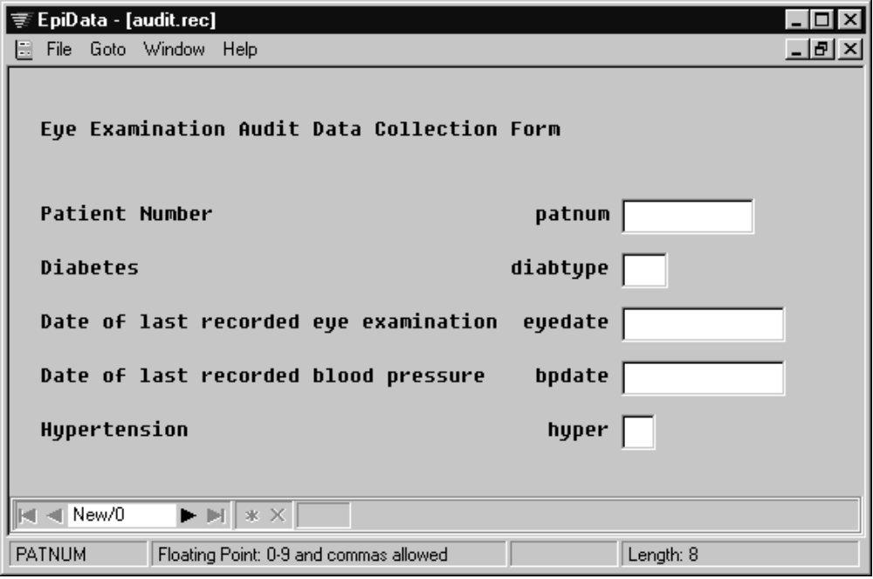

The layout of the data-entry screen should follow the layout of the data-collection form. Complex coding information can be discarded as this tends to clutter up the data-entry screen. Remember to give your variables short and meaningful names as this will make it easier to perform data-management and data-analysis tasks. It is also advisable to add some form of data checking to a data-entry system to enforce the coding scheme and apply other (e.g. range) checks. You can do this using the Add/revise checks functions of EpiData.

Creating a data-entry system

Build and test a data-entry and checking system that accurately reflects the audit survey dataset and your data-collection forms.

Sampling considerations

If all individuals in the target population are sampled then you would get a precise picture of the frequency (or prevalence) of patients meeting the audit criteria in the target population. In audit surveys, where the target population is often small, it may be feasible to sample all individuals. Such a survey would be expensive and time-consuming for a large target population so a sub-group of the target population (called the sample) is surveyed. This sample must be representative of the target population if the results of an analysis of the collected data are to be representative of the target population

A representative sample

The sample taken must be representative of the target population if the results of the audit survey are to be generalised to the target population. For a sample to be representative:

- Each individual in the target population must have an equal chance of being included in the sample.

- The selection of one individual should be independent of the selection of another individual.

Probability of error

When a sample is taken there is a probability that the sample will not be representative of the target population. In most audit surveys, a risk of 5% is acceptable. This means that there is a 5% chance that the audit survey results will not reflect the frequency of the audit criteria in the target population.

Precision

The results of a sample survey give an estimate of the results that would arise from a survey of the entire target population. If a second sample were drawn from the same target population, slightly different results would arise because of the variation of the individuals selected for the sample. This variation is known as random variation.

The sample prevalence is considered to be the best estimate of the true or population prevalence. It is called the point estimate of the prevalence. The effect of random variation can be accounted for statistically by calculating a range of values around the point estimate of the prevalence that has a specified probability of including the true value of the prevalence . The specified probability is called the confidence level and is usually 95%. The range of values that the true prevalence could take is called the confidence interval. The endpoints (minimum and maximum) of the confidence interval are called the confidence limits.

With a 95% confidence interval we are 95% sure that the confidence interval will include the true prevalence. We do not know for certain that the confidence interval includes the true prevalence. The chances are 95% that the confidence interval does include the true prevalence. The chances are 5% that the confidence interval does not include the true prevalence.

The size of the confidence interval is influenced by size of the sample taken and is usually specified, in sample size calculations, as a margin of error (i.e. the prevalence plus or minus a given margin of error). The width of the confidence interval is specified as twice the acceptable margin of error.

Sampling methods

The sampling method used for a particular audit survey will often be decided by the nature of the target population and the context of the audit survey. There are two main sampling methods used in clinical audit surveys:

RANDOM SAMPLING : This requires the existence of a sampling frame that lists every individual in the target population together with information on how to locate them. The list must be accurate and up-to-date. Individuals are randomly drawn from the list using a random number table. In most audit situations a list will be available.

SYSTEMATIC SAMPLING : This is also based upon a list of patients. Individuals are selected from the list using a sampling interval. If, for example, you required a sample size of 201 patients from a population of 1090 patients you could select every fifth patient (1090 divided by 5 = 218) from a list of eligible patients to obtain your sample. If you use systematic sampling, you should be very careful when using lists sorted by patient characteristics as you might, for example, sample a particular sex or age-group in preference to another.

Some audit surveys, particularly patient satisfaction surveys, use opportunistic or convenience sampling. With opportunist sampling each patient attending the clinic is sampled until the required number of patients have been sampled. This is often considered ‘random’ because at the start of the sampling process you do not know who will be attending. You should, however, take great care when using opportunistic sampling and ensure that you sample each clinic session.

Sample size calculations for random, systematic, and opportunistic samples are identical.

When you repeat an audit survey, it is advisable to use the same methods and criteria / standards as before. So long as the conditions of the audit are the same you do not need to look at exactly the same patients again.

Determining the required sample size

To calculate a sample size for a survey we need the following items of information:

POPULATION : An estimate size of the target population. Larger populations require a larger sample size in order to achieve a reliable result.

STANDARD : The nearer the standard is to 50%, the more individuals are needed in the sample for the same degree of precision.

REQUIRED PRECISION : How precise should the estimate be? The greater the precision required, the more individuals needed in the sample. The required precision specifies the width of the confidence interval. It is the margin of error. The precision needed also depends upon the standard. For example, if the standard is 80% then an estimate of 80% ± 5% may be acceptable whereas an estimate of 80% ± 20% is of little use.

PROBABILITY OF ERROR : What chance of accidentally drawing a non-representative sample is acceptable? The smaller the probability of error, the more individuals are needed in the sample.

Another factor needs to be accounted for:

PRACTICALITY : The best sample size yields an estimate of high precision with a small probability of error but, often, the resources or time available to an audit survey will dictate that a smaller than ideal sample be taken. It is important that a sample size that is attainable given the available resources is selected otherwise there is a risk that the audit survey will not achieve its sample and produce misleading (biased) results. You may need to compromise on the level of precision or the probability of error to make a survey practicable. You may also need to rethink the criteria / standard statements or reduce the width of the dataset (i.e. the number of variables) to be collected in order to achieve a reasonable sample size collectable within a reasonable period of time with available staff

Using SampleXS to determine the required sample size

SampleXS is a program that you can use to help you calculate the required sample size for audit surveys. In this exercise you will use SampleXS to calculate the sample size for an audit survey with a standard of 80% from a population of 390 patients:

Parameter | Value
Population size | 390
Standard | 80%
Maximum error | 5%

Start SampleXS and enter these values into the relevant data-entry boxes. Specify a design effect of 1.0 and click the Calculate button:

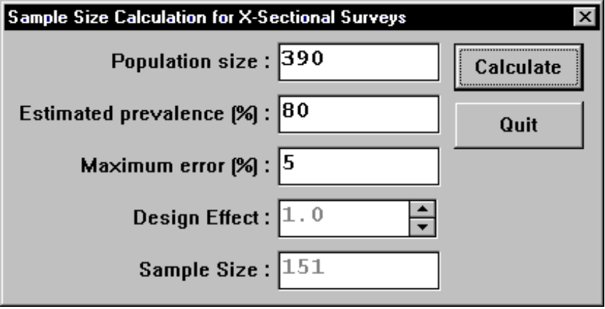

The resulting sample size (151) is the sample size required for a audit survey using random, systematic, or opportunistic sampling.

SampleXS assumes that the maximum error (i.e. the margin of error or required precision) specified is for a 95% confidence interval and that the probability of error is 5%.

With random, systematic, or opportunistic sampling you do not need to specify a design effect (i.e. set the design effect to 1.0). A design effect is only specified for complex samples (e.g. cluster samples). Complex samples are not commonly used for audit surveys.

Sample size and sampling method

Calculate the sample size for an audit survey of the routine examination of diabetic patients using the background information provided.

Practical planning tasks

There are also practical management tasks that need to be completed before an audit survey can be started. These are:

STAFFING : You should make a list of the staff time required to undertake the audit survey. It is probably best to do this by first listing the main tasks involved in executing the audit. Make sure that you allocate staff time and leave a margin for possible loss of staff due to (e.g.) ill health. Staff may need some training in using the data-collection forms and data systems.

EQUIPMENT : Make a list of the equipment required and arrange for its purchase and delivery. Audit surveys usually require very little equipment apart from consumable items such as paper for data-collection forms.

TIMETABLE : Make a detailed timetable of activities. A special type of graph called a Gantt chart is useful for project planning as it shows which activities depend upon other activities having been completed and which activities can run concurrently:

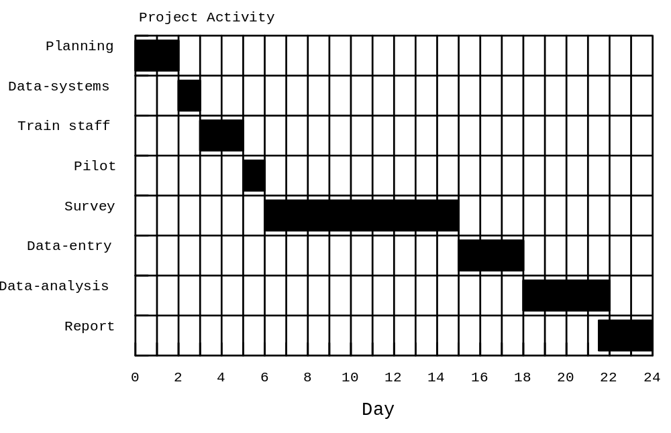

The timetable above shows the survey work concentrated over a few days. It may be desirable to spread the survey work over a longer period of time (i.e. collecting data for only a few hours per week) in order to minimise disruption and make best use of existing staff.

BUDGET : All of the above tasks should inform the size of the budget you will need to complete the survey. Make sure you build some ‘slack’ into the budget to cope for unforeseen circumstances.

Practical tasks

Complete the following tasks:

- Make a list of the members of the audit survey team giving a brief description of the main tasks and responsibilities allocated to each staff member.

- Prepare a syllabus for staff training (if required).

- Make a list of equipment required.

- Prepare an outline audit survey timetable.

- Prepare an estimated budget.

Prepare a short (c. 20 minutes) presentation of your proposed audit survey design. This should include:

- Criteria / standard statements and data-sources.

- Description of the audit survey dataset.

- Data collection form.

- Sampling strategy.

- Organisational issues (staff, budget, timetable, &c.).

Section Two - Analysis of Data from Audit Surveys

Background to the survey analysis exercise

This is a hands-on exercise that you should follow seated at your computer. It concentrates on the practical skills needed to manage and analyse data from an audit survey.

The exercise assumes a familiarity with the ANALYSIS module of EpiInfo and with basic computing and statistical concepts.

The dataset used in the exercise is to be found on the supplied floppy disk as AUDITEYE.REC. This data was collected as part of an audit of eye examinations on diabetic patients in a primary health care setting. The audit criteria and standards were:

Eighty percent of diabetic patients should have had an eye examination in the previous twelve months.

Eighty percent of diabetic patients should have had their blood pressure checked and recorded in the previous twelve months.

Ninety-five percent of patients with both hypertension and diabetes should have had an eye examination in the previous twelve months.

The audit was restricted to NIDDM patients. The practice had 353 NIDDM patients at the time of the audit (02/11/1999 à 05/11/1999). SampleXS was used to calculated the sample size with:

Eighty percent of diabetic patients should have had an eye examination in the previous twelve months.

As the primary criteria / standard statement:

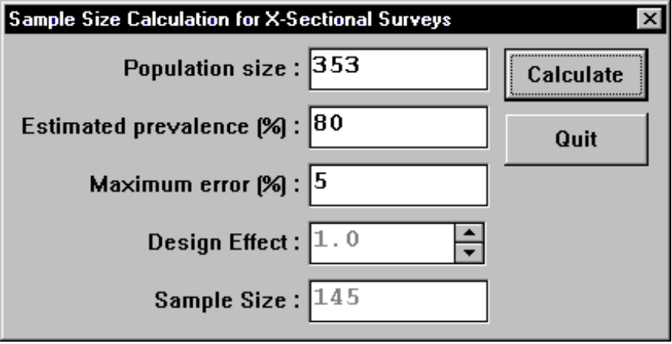

Data were extracted from 145 patient notes selected at random and recorded on a tabular data collection form and entered onto the computer using the ENTER module of EpiInfo.

The structure of the AUDITEYE.REC dataset

Data from the audit survey is stored in an EpiInfo file called AUDITEYE.REC. The following table lists the names, types, and codes of the variables in the AUDITEYE.REC dataset. The variable types and the EpiInfo pictures that would be used to define variables in EpiInfo .QES files or with the DEFINE command in EpiInfo ANALYSIS are also listed:

Variable | Contents | Type | Picture | Values / Codes
PATNUM | Patient number | Number | ######## | N/A
EYEDATE | Date of last recorded eye examination. | Date | <DD/MM/YYYY> | N/A
BPDATE | Date of last recorded BP check | Date | <DD/MM/YYYY> | N/A
HYPER | Patient is hypertensive | Number | # | 1 = YES, 2 = NO

Narrow datasets, such as this one, are typical of those collected in audit surveys.

Data management and analysis

The data-management tasks you need to perform on an audit survey dataset will depend upon the data you have collected and how you have coded it. With the sample audit survey dataset we will do some typical examination and combining of variables.

Start EpiInfo. Start the ANALYSIS module. With the supplied floppy disk in the A: drive of your computer enter the command:

read a:\auditeye.rec

To retrieve the sample audit survey dataset. Type the command:

browse

And briefly examine the dataset. Make yourself familiar with the variables in the dataset. When you have finished press ^.

The EYEDATE variable contains the date of the last recorded eye examination. We will check if the last recorded eye examination was less than a year ago. First create a new variable to hold the result of the check using the DEFINE command:

define eye12m #

And perform the check using the IF … THEN command:

if eyedate >= "05/11/98" then eye12m = 1 else eye12m = 2

The date "05/11/1998" corresponds to one year before the final day of data collection. This choice of date is somewhat arbitrary as a date corresponding to the start of the data collection or mid-way through data collection could also have been chosen. The most accurate methods would have been to have recorded the date that each patient record was examined and used date arithmetic to calculate EYE12M, for example:

if datadate - eyedate <= 365 then eye12m = 1 else eye12m = 2

The above command will not work with the sample dataset because it does not contain a variable called DATADATE corresponding the date that each patient record was examined.

In an audit survey as rapid as this one (2½ days), it makes little difference which date you use.

Data management and analysis (continued)

We can check if our first criteria / standard has been met using the FREQ command:

freq eye12m /c

Which produces the following output (the /C at the end of the FREQ command instructs ANALYSIS to calculate and display confidence intervals):

EYE12M ¦ Freq Percent Cum. 95% Conf Limit
-------+--------------------------------------
1 ¦ 127 87.6% 87.6% 81.1%-92.5%
2 ¦ 18 12.4% 100.0% 7.5%-18.9%
-------+--------------------------------------
Total ¦ 145 100.0%

The criteria / standard that 80% of diabetic patients should have had an eye examination in the previous twelve months has been met.

The same process can be used to test the criteria / standard statement:

Eighty percent of diabetic patients should have had their blood pressure checked and recorded in the previous twelve months.

Enter the following commands:

define bp12m #
if bpdate >= "05/11/1998" then bp12m = 1 else bp12m = 2
freq bp12m /c

Which produce the following output:

BP12M ¦ Freq Percent Cum. 95% Conf Limit
------+--------------------------------------
1 ¦ 124 85.5% 85.5% 78.7%-90.8%
2 ¦ 21 14.5% 100.0% 9.2%-21.3%
------+--------------------------------------
Total ¦ 145 100.0%

The criteria / standard that 80% of diabetic patients should have had their blood pressure checked and recorded in the previous twelve months has been met. If you examine the 95% confidence interval you will see that there may still be some room for improvement.

The final criteria / standard statement:

Ninety-five percent of patients with both hypertension and diabetes should have had an eye examination in the previous twelve months.

Is also simple to analyse. First we use the SELECT command to select only those patients with hypertension:

select hyper = 1

And then use the FREQ command to check if the standard has been met

freq eye12m /c

Data management and analysis (continued)

The command FREQ EYE12M /C produces the following output:

EYE12M ¦ Freq Percent Cum. 95% Conf Limit
-------+--------------------------------------
1 ¦ 38 88.4% 88.4% 74.9%-96.1%
2 ¦ 5 11.6% 100.0% 3.9%-25.1%
-------+--------------------------------------
Total ¦ 43 100.0%

The sample size is small (there are only 43 hypertensive patients in the sample) but it appears that the criteria / standard that 95% of patients with both hypertension and diabetes should have had an eye examination in the previous twelve months has not been met.

Results and further analysis

Analysis of the data tells us if our criteria and standards have been met:

Criteria / Standard | Result
Eighty percent of diabetic patients should have had an eye examination in the previous twelve months. | OK
Eighty percent of diabetic patients should have had their blood pressure checked and recorded in the previous twelve months. | Room for improvement
Ninety-five percent of patients with both hypertension and diabetes should have had an eye examination in the previous twelve months. | Room for improvement

The first remedial step to take might be to recall the patients who fall outside of our criteria/ standards. A list of patient numbers for recall can be produced using the following commands:

select
select eye12m = 2 or bp12m = 2
list

In order to create a comprehensive list you will need to collect and enter data from patient records not already sampled in the audit survey.

This list could also form the basis of an analysis (through further examination of patient notes) of whether the problem is likely to be one of service-deficit (i.e. some diabetic patients are either not invited to attend the diabetic clinic sessions or do attend the diabetic clinic sessions but the proper examinations are not being performed and / or recorded) or one of patient-deficit (i.e. the patient is invited to attend the diabetic clinic sessions but does not attend them regularly). It is important to consider whether a perceived patient-deficit is, in fact, a service-deficit (e.g. the time and dates of the diabetic clinic sessions do not suit patients doing shift work or working in the market).

Negative results in audit surveys should always be translated into remedial action and the audit survey repeated at regular intervals until you are confident that your criteria and standards are being met on a regular basis.

